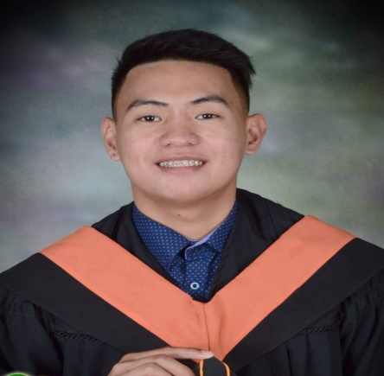

**MELVEN JOHN T. AQUINO**

San Eugenio, Aringay, La Union

09663692417

Email:melvenaquino60@yahoo.com

**Objective**

To use my knowledge and skill in meeting my objectives and fulfilling my responsibility as the jobs requires. To be open and responsive to learning opportunities that will advance my professional growth.

**Educational Background**

**2014-2018 Bachelor of Science in Hotel and Restaurant Management**

Don Mariano Marcos Memorial State University

MID, La Union Campus

Brgy. Catbangen, City of San Fernando, La Union

**2010-2014 Aringay National High School**

Poblacion, Aringay, La Union

**2009-2010 Aringay Central Elemetary School**

Poblacion, Aringay, La Union

**Work Experience**

**Bread and Pastry NC II**

Technical Education and Skills Development Authority

December 2017

**Fod and Beverage NC II**

Technical Education and Skills Development Authority

June 2018

**On the Job Training**

Baguio Country Club

Baguio, City

**Mang Inasal**

Grill Man/Servie Crew

Agoo, La Union

**Mcdonald’s KSA**

Barista/Service Crew

Jeddah Saudi Arabia

**Special Skill**

* Work Independently
* Decision Making
* Good organizational skills
* Able to do well in Food and Beverage service
* A team player and Customer-Oriented Person
* Dynamic, Creative, self-motivated and focused to any job assignment

**Achievements**

Personal Information

**Age:**  25 yrs old

**Date of Birth:**  August 18, 1997

**Place of Birth:** Agoo, La Union

**Civil Staus:**  Single

**Religion:** Roman Catholic

**Citizenship:** Filipino,English

**Character References**

**Maam, Arlene Dejos Maam, Rishelle B. Nucaza**

Chairperson (Hrm Department) Instructor ( BSHRM,Department)

DMMSU-MLUC DMMMSU-MLUC

City,of San Fernando La Union Naguilian, La Union

09228853155 09463670245

***By affixing my signature below, I signify that the information started hereon is correct.***

MELVEN JOHN T. AQUINO